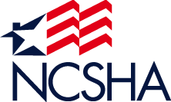
National Council of State Housing Agencies
2019 HFA Institute
January 13-18, 2019
Washington, DC

Shipping Instructions
All materials and handouts for NCSHA's 2019 HFA Institute should be shipped to arrive no earlier than 5 days prior to your arrival, to the conference hotel and labeled as follows:
Hold For: <your name> Arrival: <your arrival date>
Group Name: NCSHA’s 2019 HFA Institute (January 13-18)
c/o FedEx Office at JW Marriott Washington, DC
JW Marriott Washington, DC
1331 Pennsylvania Avenue, NW
Washington, D.C. 20004
Box ____of____
Please also include your return address on the shipping label. If you have any questions in advance of the meeting or to check on shipment arrival, contact Victoria Lewis in the FedEx office at 202-347-1351.

Due to the high volume of materials sent to the meeting, NCSHA is unable to handle boxes or their contents on site. To have your package delivered when you arrive at the hotel, please contact the Receiving Department at extension 6671. (Packages can be delivered 24 hrs) Please allow 45 – 60 minutes for delivery time. To expedite the process, please be sure to have the appropriate tracking information with you. You must be present to accept the delivery. Most importantly, don’t forget to bring your handouts to the session at which you are speaking.

Receiving Packages – Handling and Storage Fees for incoming packages are as follows:

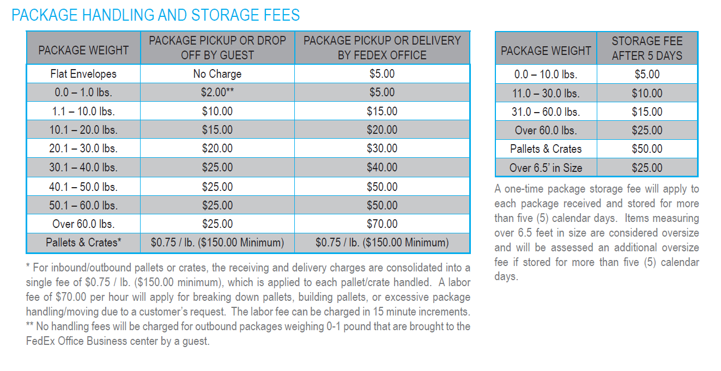

Business Center
The FedEx Office Print and Ship Center in the JW Marriott is equipped to handle your computer, photocopying, and printing needs. Even when closed, guests still have access to computer and copying services. For more information, please contact the Print and Ship Center directly as follows:
Onsite Contact: Victoria Lewis  - 202-347-1351 phone  - 202-347-1292 fax  - Victoria.lewis@fedex.com | Hours of Operation:  - Mon-Fri 7:00 a.m. – 7:00 p.m. (24 hr guest access)  - Saturday 8:00 a.m.– 1:00 p.m. (24 hr guest access)  - Sunday CLOSED (24 hr guest access)

